**Squash Rules**

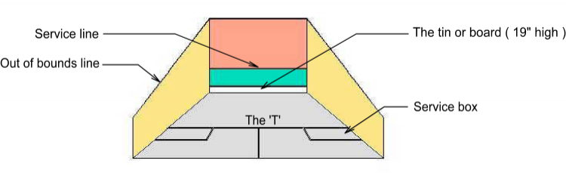

The basic rules of squash are fairly simple. First the winner of the toss gets to choose which side they want to serve from and alternates sides until they lose a point. The toss is typically done by spinning the racquet, with one player guessing whether the racquet will land up or down based on the direction of the logo at the end of the grip. The ball can hit any number of walls ( i.e sidewall, backwall ) but must eventually hit the front wall before bouncing on the floor. A rally ( the exchange of shots ) ends when one of the following occurs:

• The ball bounces twice

• The ball hits the tin

• The ball is hit outside the out lines

• Interference resulting in a stroke, i.e. point to the obstructed player.

The serve is done by having at least one foot in the service box, then hitting the ball to the front wall, above the service line and having it bounce in the opposite quarter-court. The receiver can stand anywhere as long as they do not interfere with the server. Only one serve is allowed. There is no second serve as in tennis.

Your opponent has the option of volleying return your serve before it hits the ground. After hitting the front wall first, the ball may hit any other number of walls before landing in the opponent’s quarter court. However, a serve is illegal if it hits any sidewall *before*hitting the front wall! Following the serve, the ball can hit any number of sidewalls before hitting the front wall.

The red lines mark the out of bounds of the court. So all shots must be below the lines. If the ball touches the line it is considered out!

Scoring is to 11 or point-a-rally ( PAR ), where every rally is a point, regardless of who served. So if you serve and lose the rally, then your opponents get a point and gets to serve. The professionals play best of five games , PAR scoring to 11. Where the score reaches ten all, the game will be won by two clear points (which will be expressed as 11-10, irrespective of the actual score ).

You also have traditional English scoring to 9 points, where only the server can win a point. This means if you serve the ball and lose the point, then your opponent gets to serve and the score does not change. If you win the point , then you get a point and get to serve from the next side. When service changes it is often called 'hand-out'. When hand-out you can pick which side to serve from, after which you alternate sides if you continue to win points. The first player who gets to 8-8 chooses 9 or 10, called set 1 or 2.

The 11 point scoring is now the official scoring for squash so one should only use this to avoid confusion.

Some not-so-obvious rules of squash are you can not carry the ball or hit the ball twice, but you can make several attempts at striking the ball as long as only contact is made once.

**Understanding interference**

Regarding interference, one should always say "Let please" whenever you sense interference may occur. In the interest of safety one should never play the shot and allow the interference to occur. If your opponent is interfering with your path to the ball, it is usually a "Let" or play the point again. If your opponent is interfering with your direct swing to the ball, then it should be "stroke" or your point. There are a lot of grey areas and many other situations that could change the call. With experience you will learn what is let , no let, and stroke. As a beginner it is best to play a let on most interferences.

In squash you must make every effort to clear your shot to give your opponent direct access to the ball once you have played it. In other words you can not play your shot and remain standing directly in the path your opponent would take to retrieve your shot.

When interference does occur it results in either a "Let" which is to replay the point or a "Stroke" which is a point to the person who's shot was obstructed. Keep in mind the following rule of thumb regarding Let and Stroke.

Interference far from ball (>1m):

• Could have got to it --> LET (replay point)

• Otherwise --> NO LET

Interference close to ball (<1 m):

• Could have hit it --> STROKE (i.e your point!)

• Otherwise --> LET

In the interest of safety you must NEVER attempt any shot that has a risk of either the ball or the racquet hitting your opponent. The correct thing to do is to hold your shot and ask for a "let". In the case where your shot would have hit your opponent you can ask 'Let Please'. Your opponent should then award you the stroke if there is no referee.

If the ball hits the opponent, it depends where the ball is going. If going to front wall then stroke, if going to side wall then let. This is the simple answer though there are other situations that can result in other calls.

**Turning a full circle before hitting the ball**

Turning is when you rotate 360 degrees about a point, i.e spin one revolution around. The rule regarding turning has been changed in the 2001 rules. Turning is allowed, but now if the opponent is hit with the ball after the striker has turned the stroke is awarded to the **opponent**. However, if the opponent makes a deliberate movement to intercept the shot then the stroke is awarded to the striker. In general if you want to turn and do not know where your opponent is, you should hold your shot and appeal for a let which should be granted. If you are sure that your shot after turning will miss your opponent then you are entitled to continue with the rally and no penalty applies. If you find that in playing your shot after turning your swing is interfered with by the opponent not moving out of the way, you can request a let for interference. The let should be granted.